Activity

**Aim:** Create API on IBM Cloud using API management service with Cloud Function operations

**Learning outcome**: Skills on creating RESTful APIs and working with them

**Duration**: 50 hours

**List of Hardware/Software requirements**:

1. Laptop/Computer with Windows OS / Ubuntu
2. User account on IBM Cloud

Step 1 – Go to IBM Cloud API Management. There are 2 options – API Gateway and API Connect.

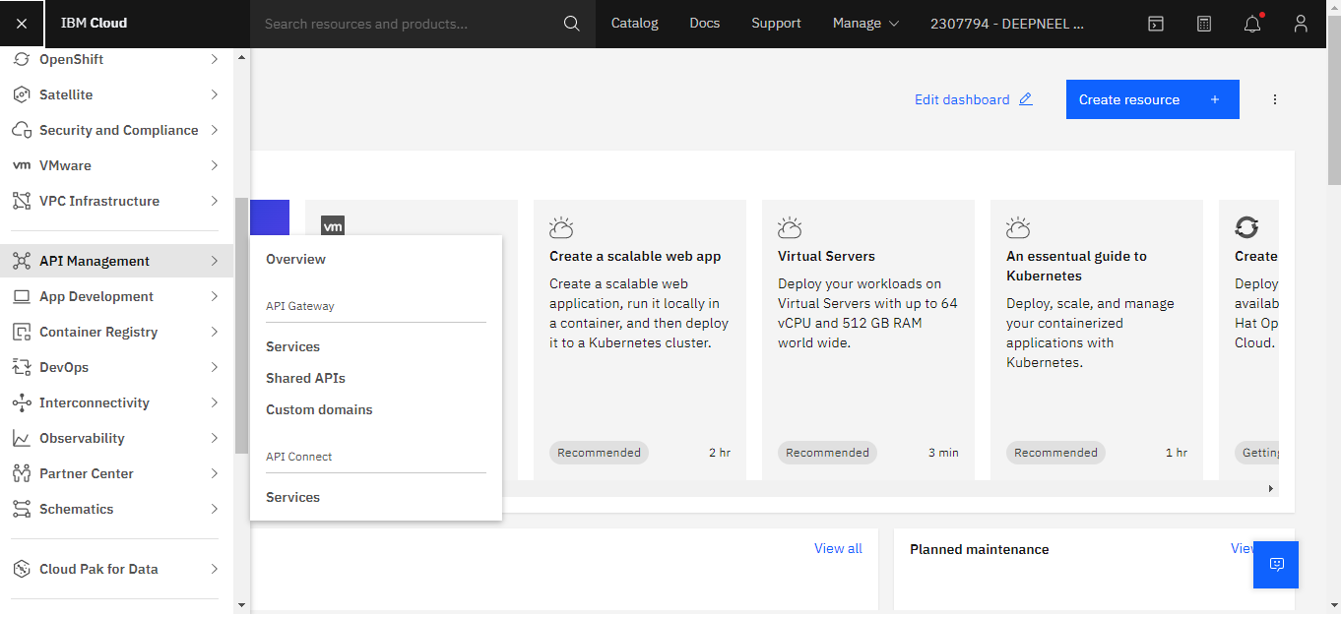

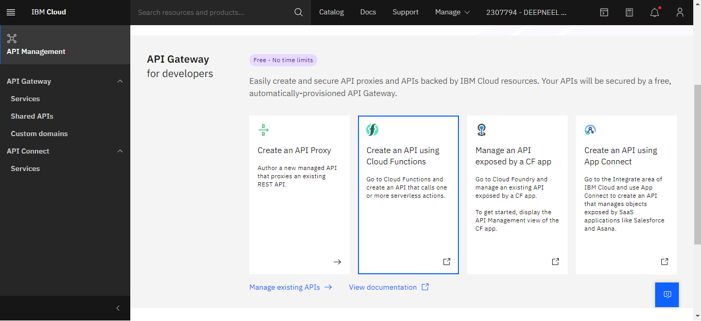

Step 2 – Select “Create an API using Cloud functions”. Then click “Create API”. Now at least 1 function need to be created at the beginning. As there is none, Create Operations will remain disabled.

Step3 – From left panel, click on “Actions” to create functions.

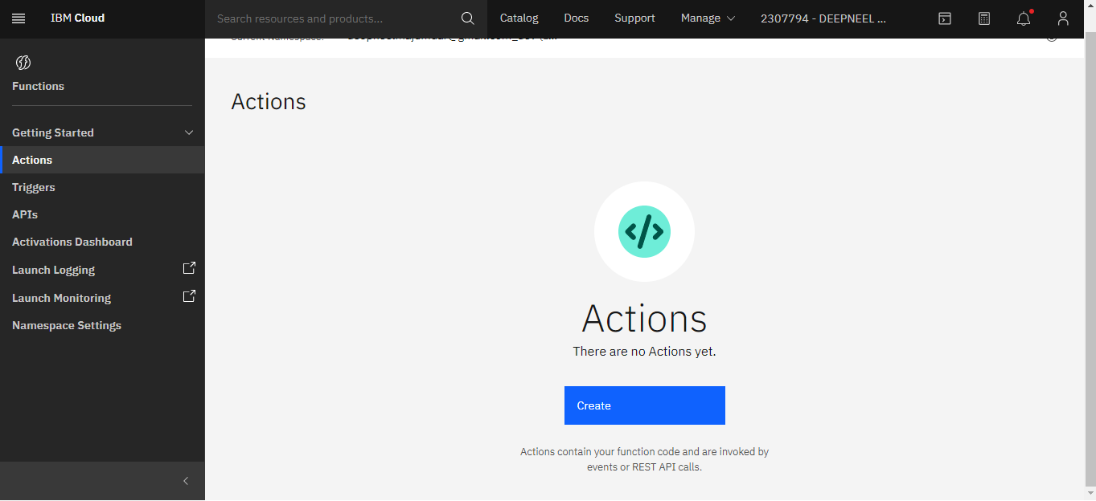

Step 4 – Click “Create”.

Step 5 – Give **name**. Select either Default package or create package (say, “api1”). Select runtime (say Python 3.9) and create.

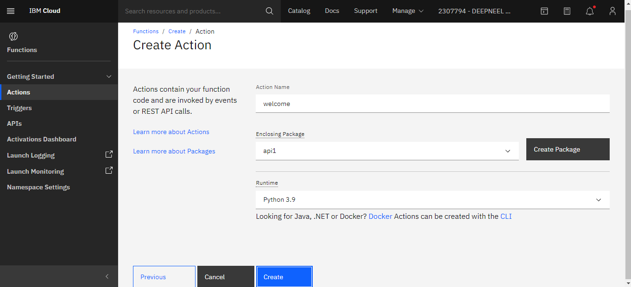

Step 6 – Code block may be displayed. You can edit the message to – “Welcome to api1”. Then Save.

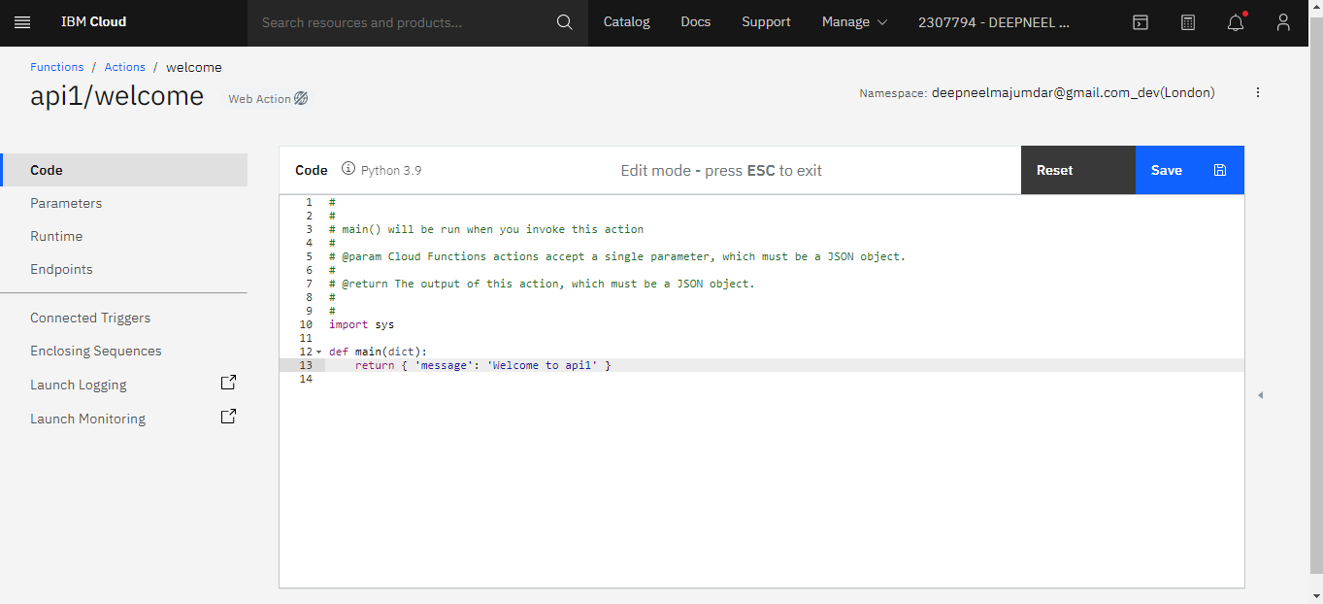

Step 7 – We can invoke to check the output.

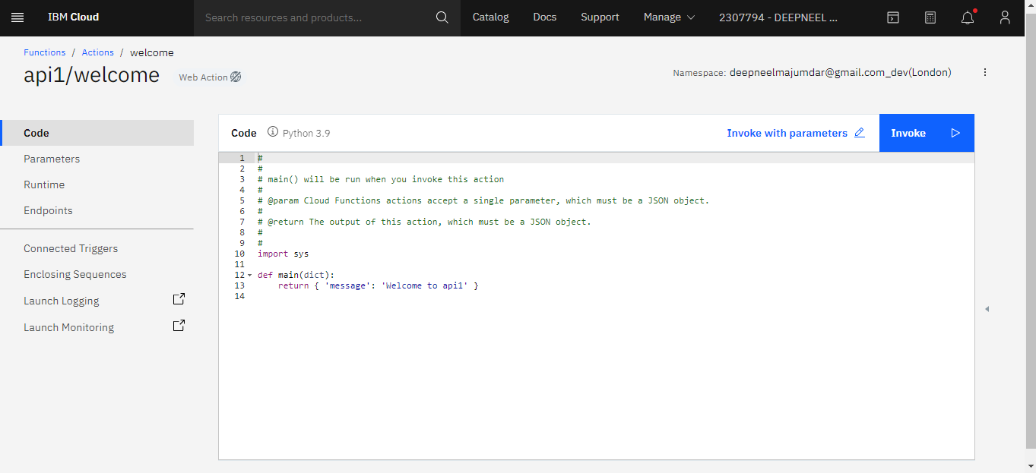

**Output/Results snippet:**

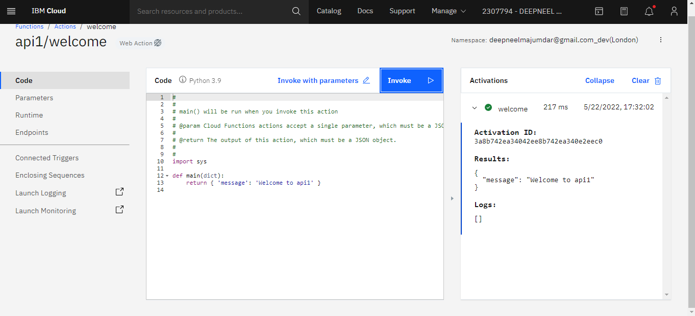

Activity

**Aim:** Extend API with multiple related functionalities

**Learning outcome**: Skills on creating RESTful APIs and working with them

**Duration**: 50 hours

**List of Hardware/Software requirements**:

1. Laptop/Computer with Windows OS / Ubuntu
2. User account on IBM Cloud

Follow the steps 1 to 7 from the previous program, and then continue with the following:

Step 1 – Go back to “Actions”. Create another Action (say, “Square Root”). Select “api1” package. Choose Runtime as Python 3.9. Then click “Create”.

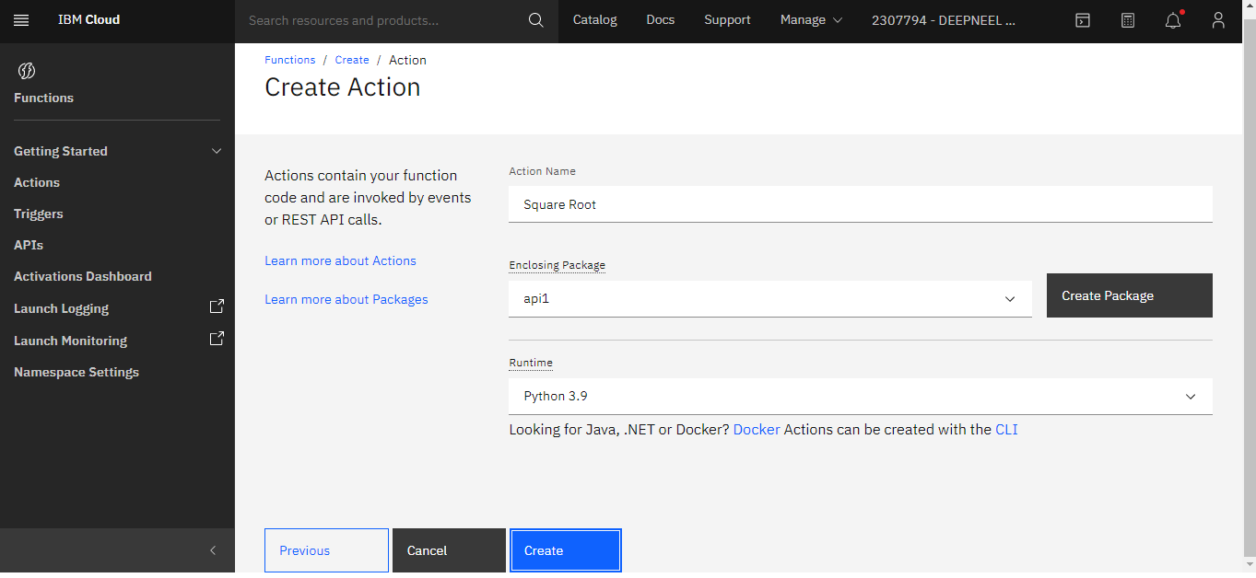

Step 2 – Edit the code

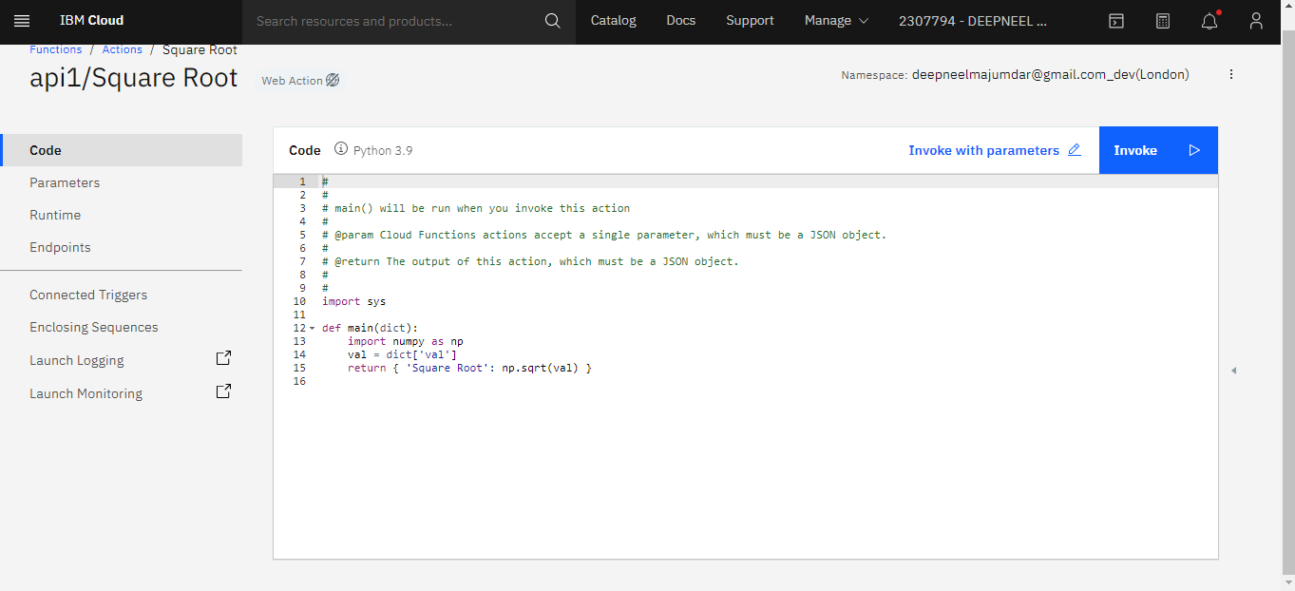

Step 3 – Save and click “Invoke with parameters”

Step 4 – Write and specify the parameters. Then “APPLY” and “INVOKE” to check the output.

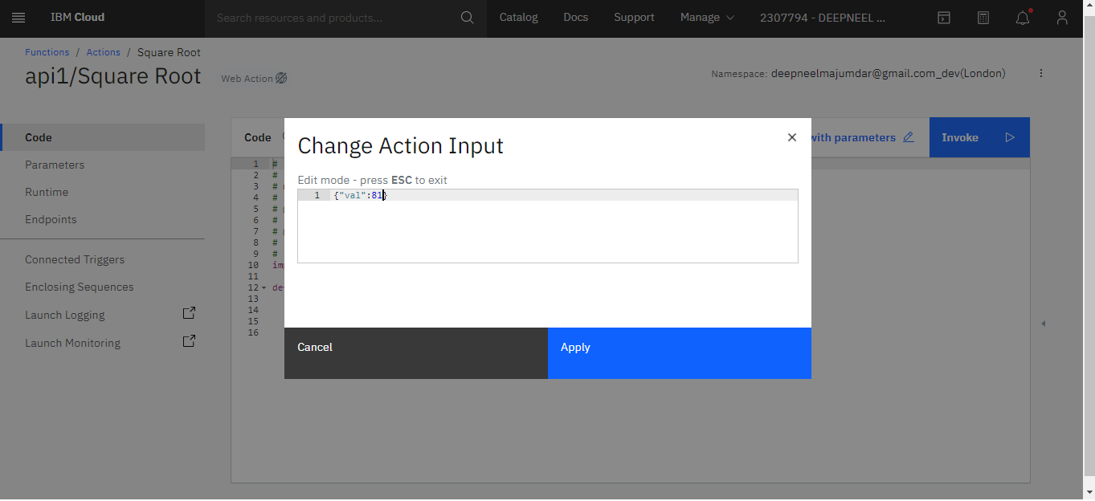

Step 5 – Go back to **Actions**

Step 6 – From the left panel, click APIs

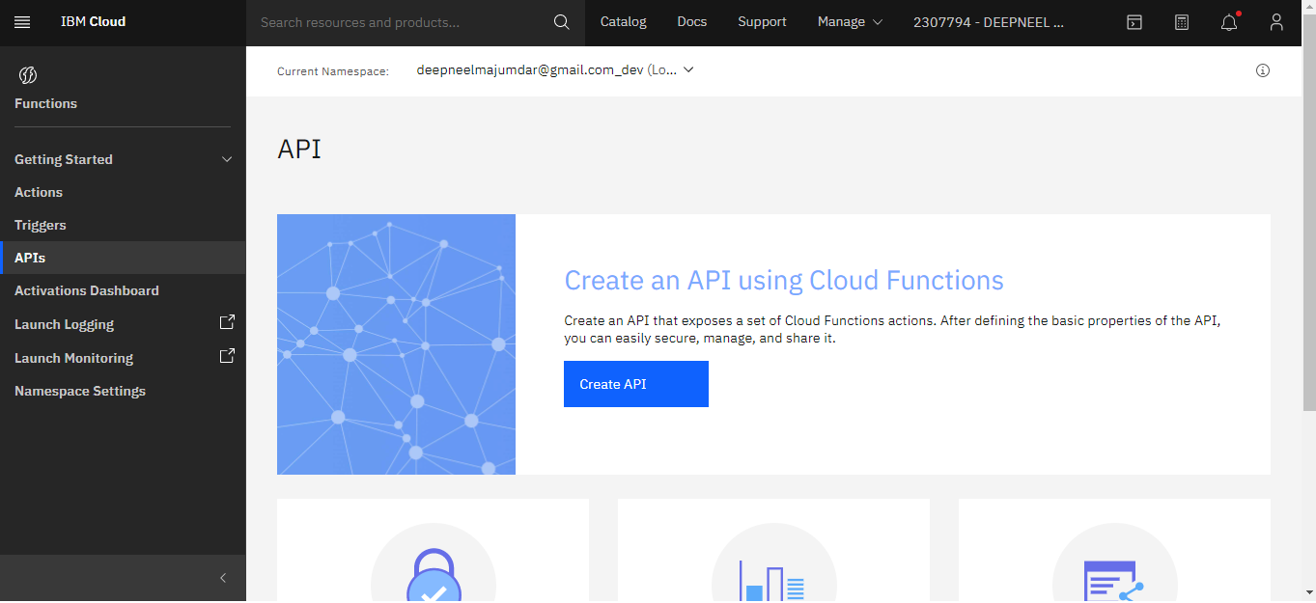

Step 7 – Create API. Give API name (demoapi). Create operation. Path -> /welcome. Verb -> GET. Package -> apione. Action -> welcome. Response -> application/json -> Create

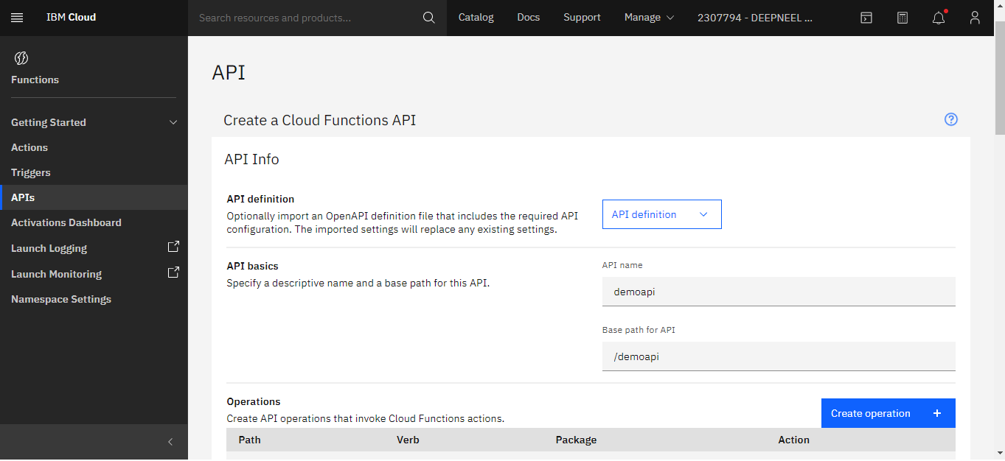

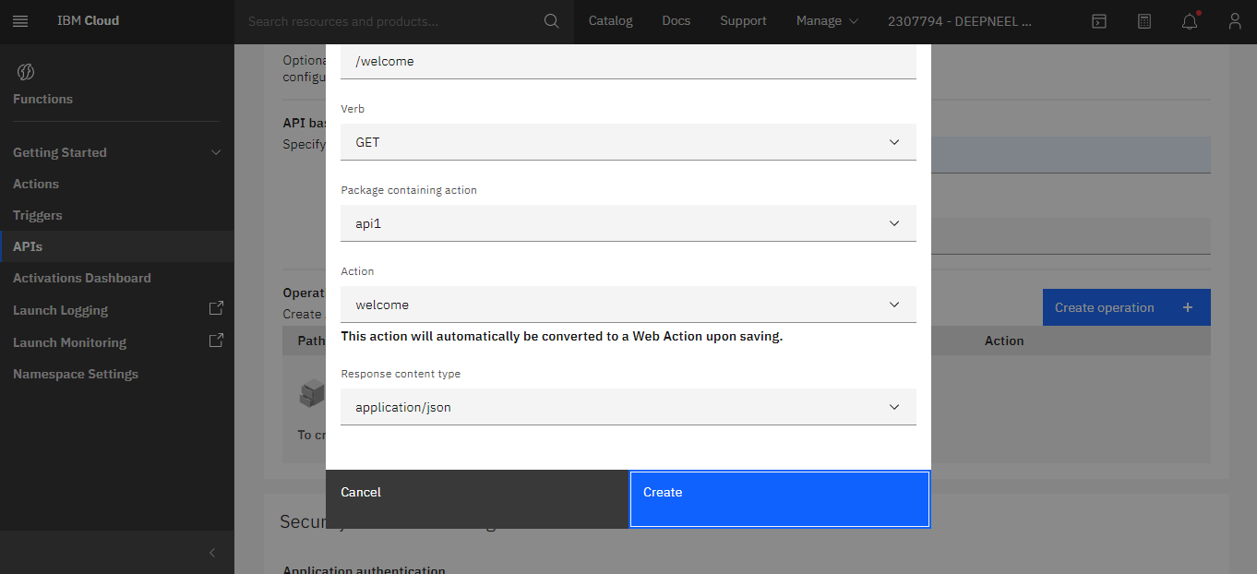

Step 8 – Again Create Operation. Path -> /squareroot. Follow Step 7 and Create

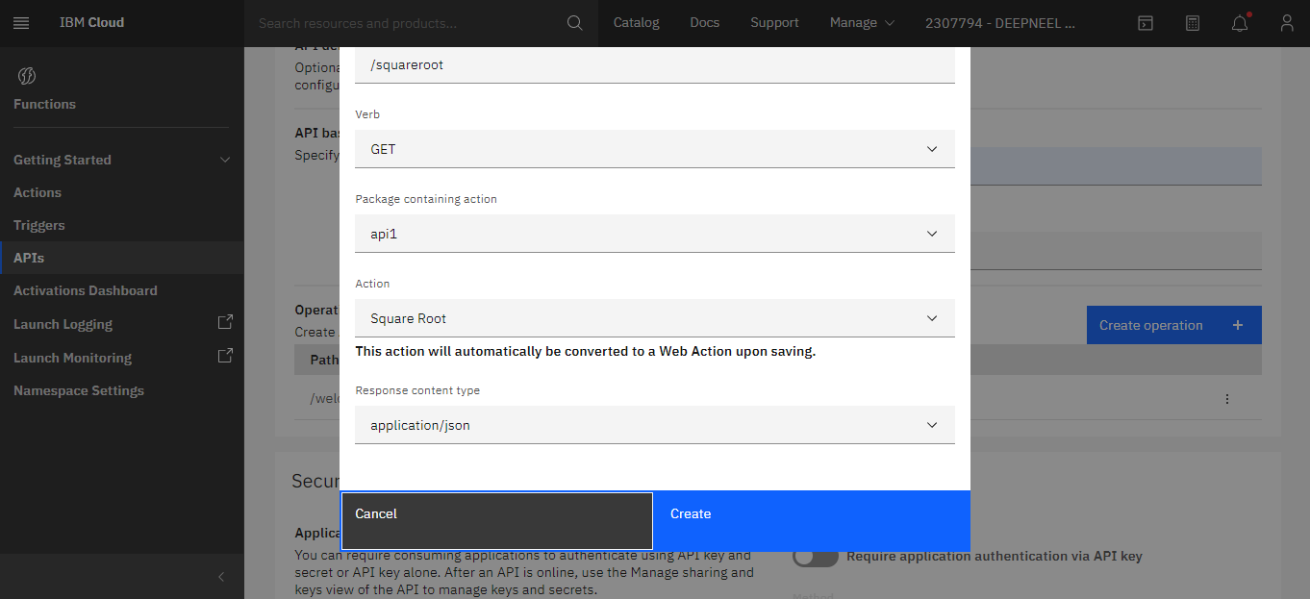

Step 9 – Click on Create

Step 10 – Toggle button is there at the Top Right to SWITCH ON/OFF.

We can copy the API’s endpoint URL and access by providing the function’s endpoint.

Example – URL/welcome

Example – URL/fundvalue?rate=5&years=15&pv=500000

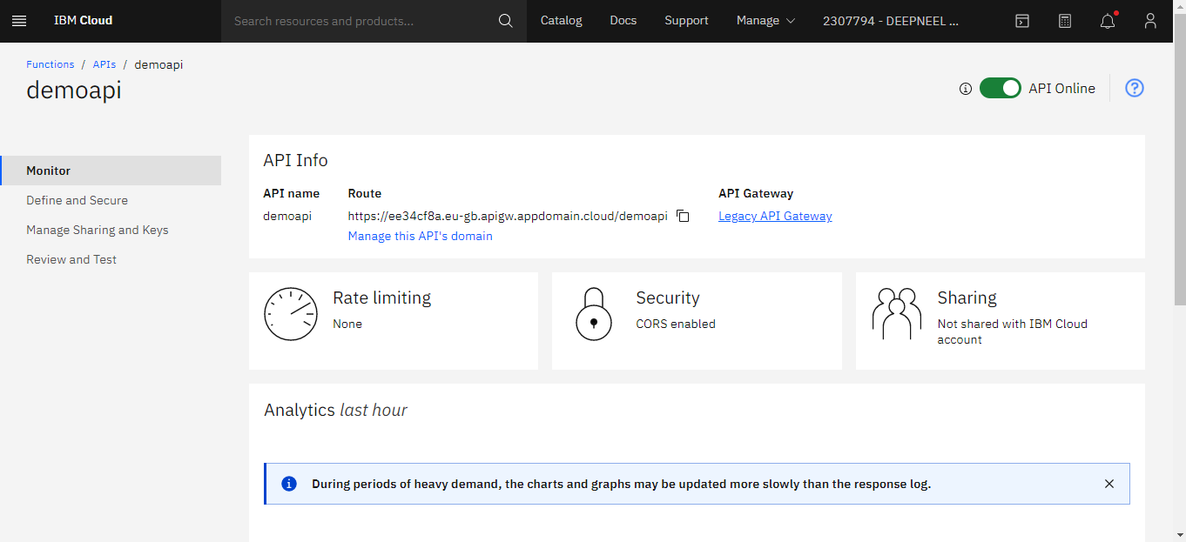

**Output/Results snippet:**

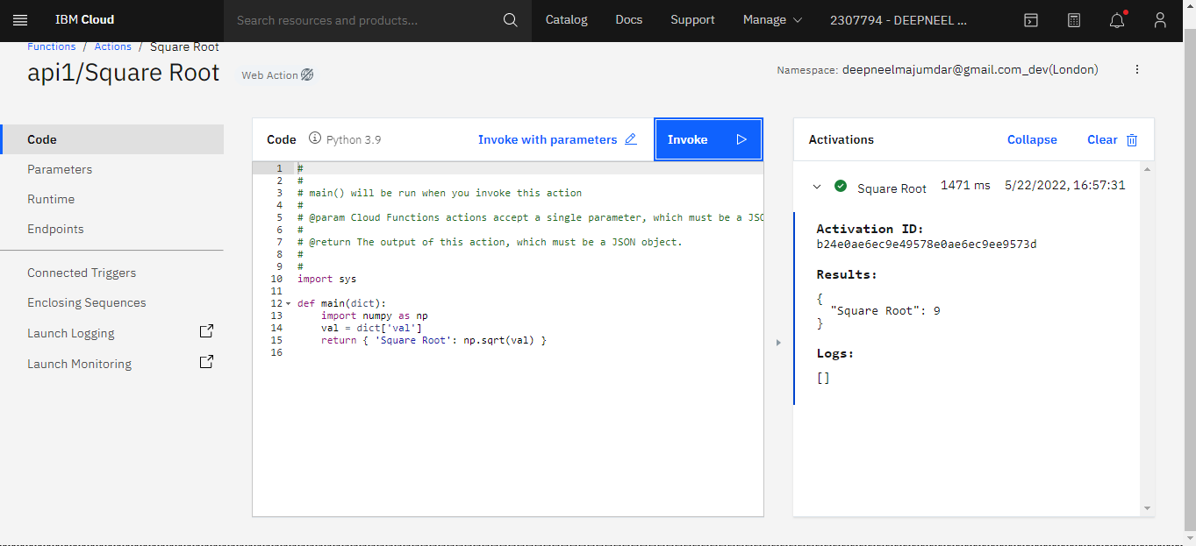

Activity

**Aim:** Connect web app hosted in cloud with API service and make functionalities available over different routes to web app

**Learning outcome**: Skills on creating RESTful APIs and working with them

**Duration**: 50 hours

**List of Hardware/Software requirements**:

1. Laptop/Computer with Windows OS / Ubuntu
2. User account on IBM Cloud

Step 1 – Create a web app (say in python). We can use the api URLwith different functions to display different outputs.

Example – let’s name this program as “webappdemo.py”. We will use /welcome route.

***import requests***

***response = requests.get("https://ee34cf8a.eu-gb.apigw.appdomain.cloud/demoapi/welcome”)***

***print(response.text)***

Step 2 – We will use /squareroot route.

***import requests***

***response = requests.get("https://ee34cf8a.eu-gb.apigw.appdomain.cloud/demoapi/squareroot",json={"val":25})***

***print(response.json())***

**Output/Results snippet:**

